PART A
(Part A: TO BE REFFERED BY STUDENTS)
Experiment No. 05
A.1 AIM:
Implement basic JavaScript operators, conditional statements, loops etc.
A.2 Pre requisite:
Basic Knowledge of HTML and JavaScript
A.3 Outcome:
After successful completion of this experiment students will be able to:
- Create formatted web pages/websites with attractive look and feel
- Use various JavaScript features
A.4 Theory:
JavaScript is the programming language of the Web. All modern HTML pages are using JavaScript.
JavaScript is one of 3 languages all web developers MUST learn:
- HTML to define the content of web pages
- CSS to specify the layout of web pages
- JavaScript to program the behavior of web pages
JavaScript operators
JavaScript operators are symbols that are used to perform operations on operands.
There are following types of operators in JavaScript.
- Arithmetic Operators
- Comparison (Relational) Operators
- Bitwise Operators
- Logical Operators
- Assignment Operators
- Special Operators
JavaScript Loops
The JavaScript loops are used to iterate the piece of code using for, while, do while or for-in loops. It makes the code compact. It is mostly used in array.
There are three types of loops in JavaScript.
- for loop
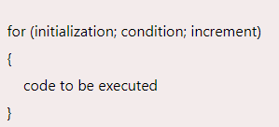

- while loop
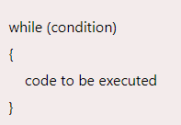
- do-while loop
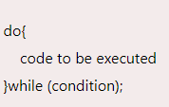

A.5 Procedure/Task:
- Write a JavaScript program to find the area of a triangle where lengths of the three of its sides are 5, 6, 7.
- Write a JavaScript program to compute the sum of the two given integers. If the two values are same, then returns triple their sum.
- Write a JavaScript function that reverse a number.
- Write a JavaScript function that accepts a string as a parameter and converts the first letter of each word of the string in upper case.
- Write a JavaScript conditional statement to find the largest of five numbers. Display an alert box to show the result.
- Write a JavaScript program which compute, the average marks of the following students Then, this average is used to determine the corresponding grade.
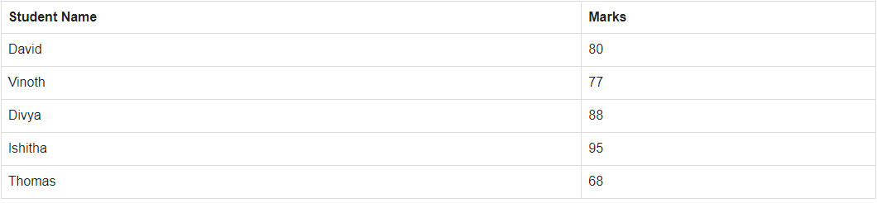
The grades are computed as follows:
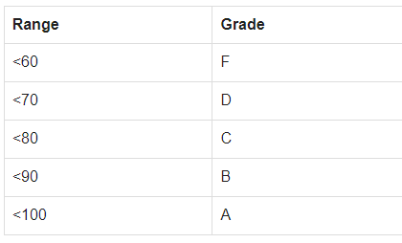
- Write a JavaScript program to construct the following pattern, using a nested for loop.
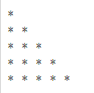
PART B
(PART B: TO BE COMPLETED BY STUDENTS)
(Students must submit the soft copy as per following segments within two hours of the practical. The soft copy must be uploaded on the Blackboard or emailed to the concerned lab in charge faculties at the end of the practical in case the there is no Black board access available)
Roll No. : E258 | Name: Kundan S. Patil
Class : B Tech CS | Batch : A-3
Date of Experiment : 08/02/2025 | Date/Time of Submission :09/02/2025
Grade :

B.1 Code:
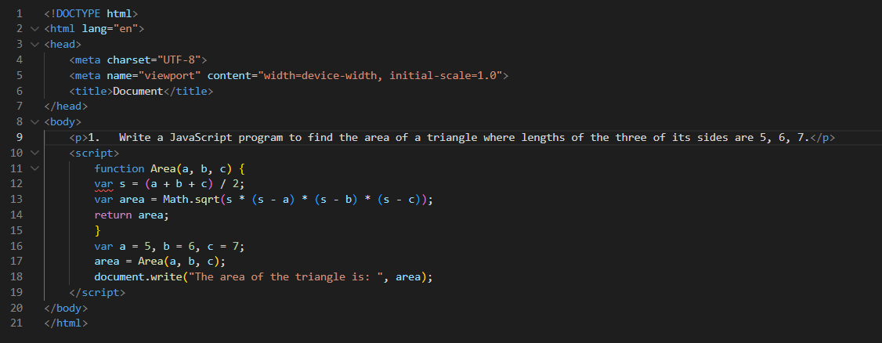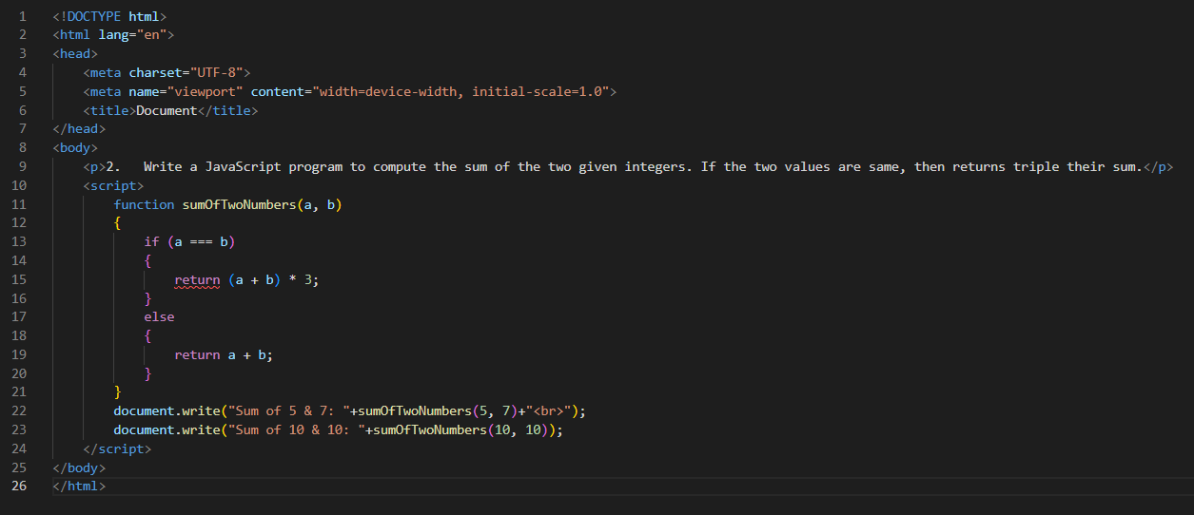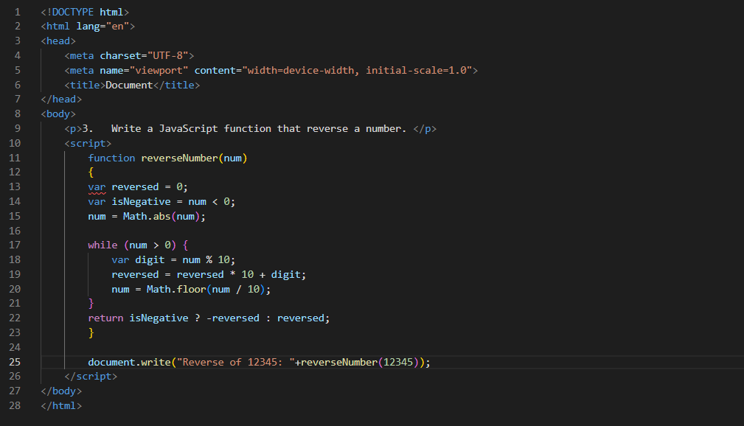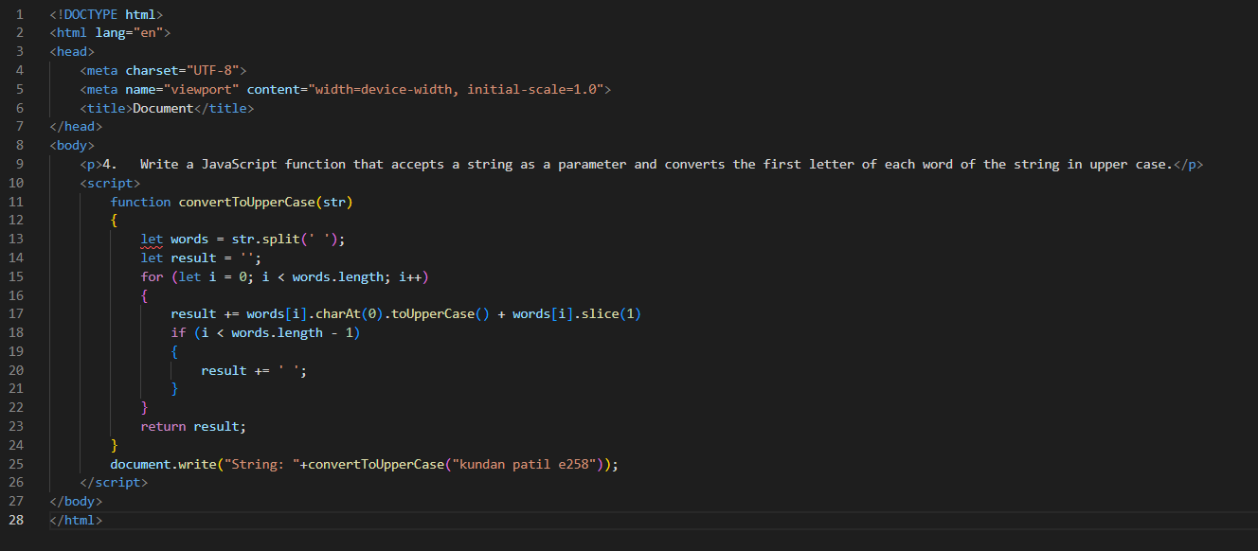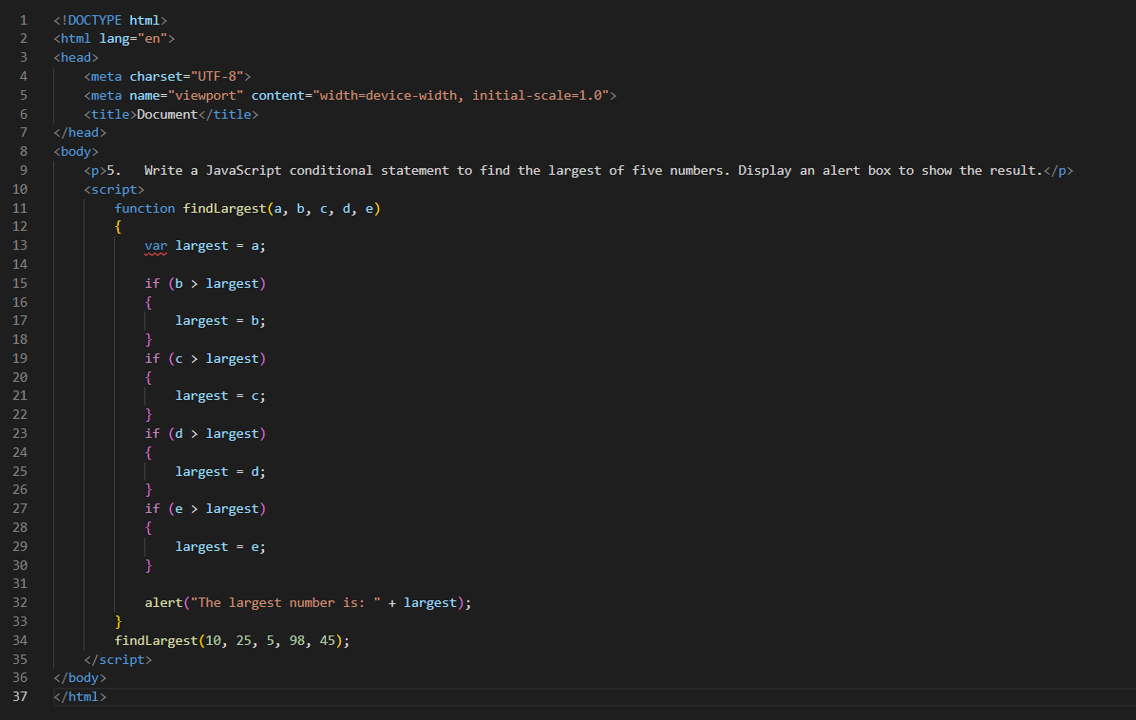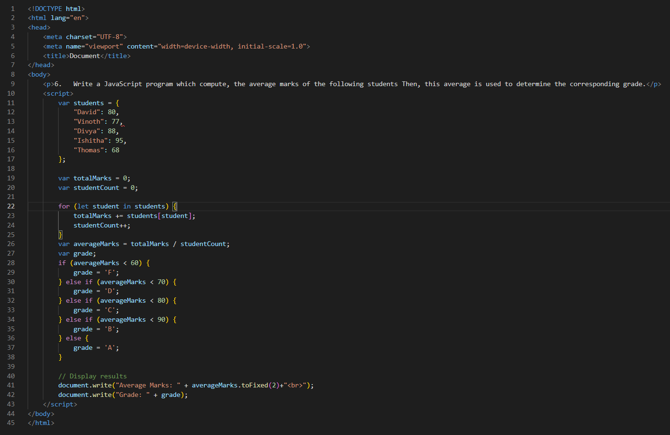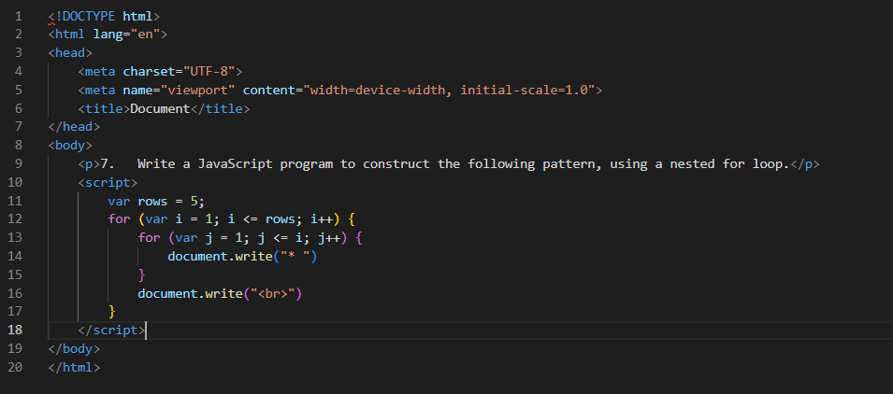
B.2 Output
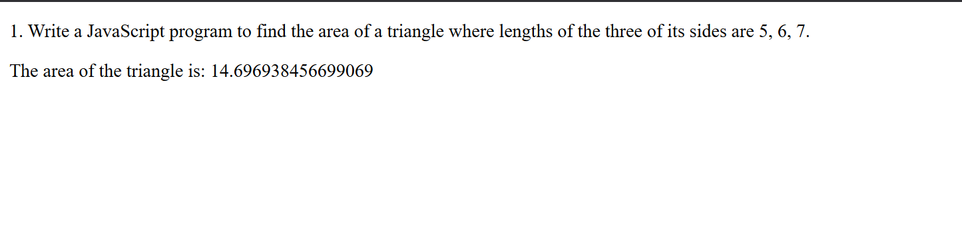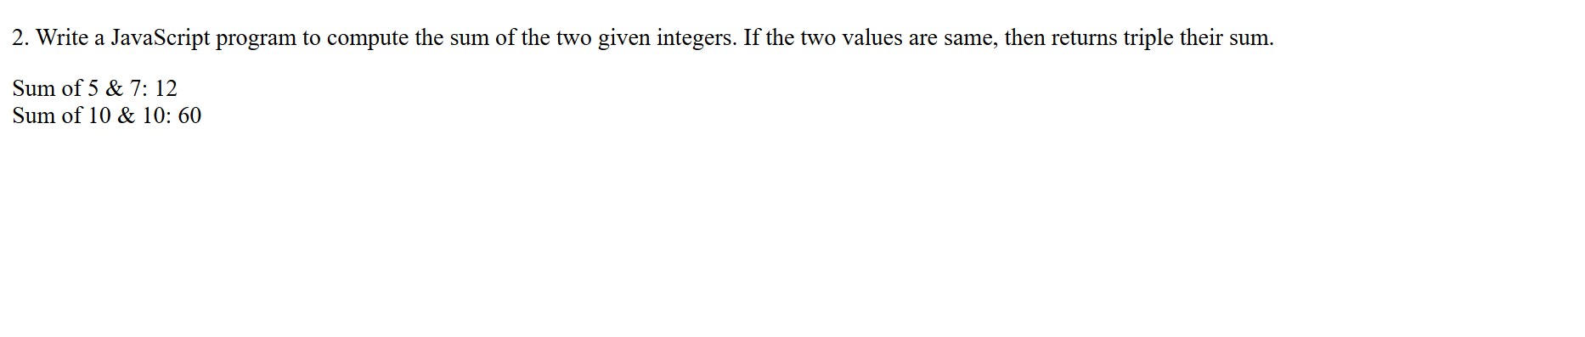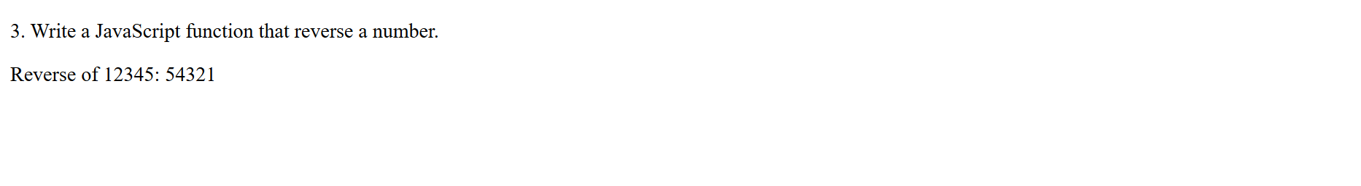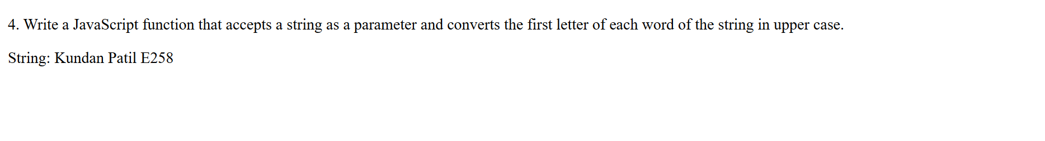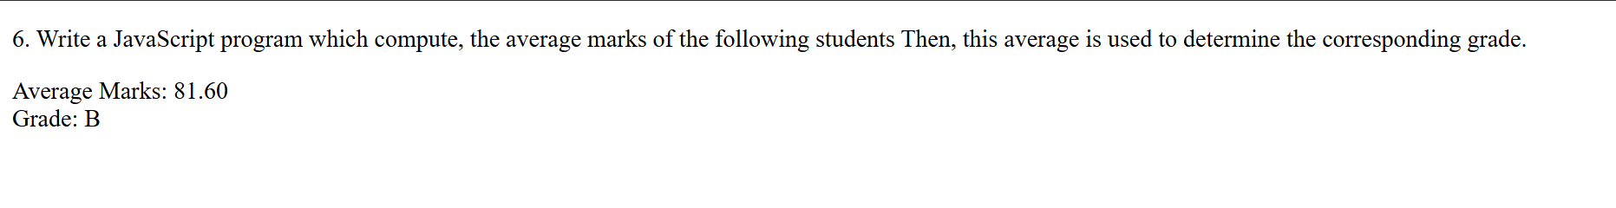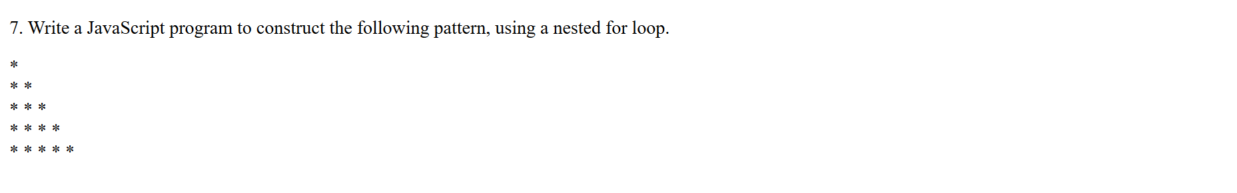

B.3 Conclusion:
After successfully completing this experiment, I have gained hands-on experience with JavaScript operators, conditional statements, and loops. I can now implement fundamental JavaScript functionalities to create interactive and dynamic web pages.
B.3 Observations and Learning:
• Understanding JavaScript Operators – Learned how arithmetic, comparison, logical, and assignment operators function.
• Using Conditional Statements – Practiced if, else if, and else to make logical decisions in programs.
• Implementing Loops – Used for, while, and do-while loops to iterate over data efficiently.
• Working with Functions – Created reusable functions to perform tasks like reversing numbers and capitalizing words.
• Pattern Printing with Nested Loops – Constructed patterns using loops and string concatenation.
• Computing and Assigning Grades – Applied logic to process student marks and determine grades dynamically.
• Triangle Area Calculation – Used mathematical formulas and JavaScript operators to compute values.

